**Gitlab**

**The single application for the entire DevOps lifecycle**



# **Gitlab**

# Gitlab is a web-based git repository that offers free open and private repositories, issues-following, and wikis. It is a complete DevOps Platform that allows teams to collaborate and build better software. GitLab Inc. is an open-core company that provides GitLab, a DevOps software package that combines the ability to develop, secure, and operate software in a single application.

# GitLab is The DevOps platform that empowers organizations to maximize the overall return on software development by delivering software faster and efficiently.

* Gitlab is the service that allows you to host your project on a remote repository & has additional features to help in SDLC and CI (Continuous Integration), and CD (Continuous Deployment), and has features like, Managing, Sharing, Wiki, Bug tracking, CI & CD.
* Gitlab Helps teams to reduce their cycle time and development costs

# **How to Add Issues in Gitlab**

In Gitlab, issues can be created by clicking on the option of the issue available on the right side of the page. The Issues have options like

* List
* Boards
* Service Desk
* Milestones

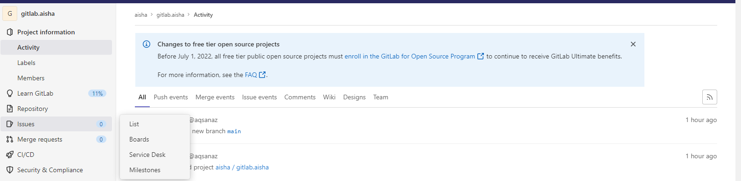

## New Issue

To add the issue, select the option of the issue and click on **List.** A new page opens with two options

1. **New Issue**
2. **Import Issue**

* **Import CSV**
* **Import From Jira**

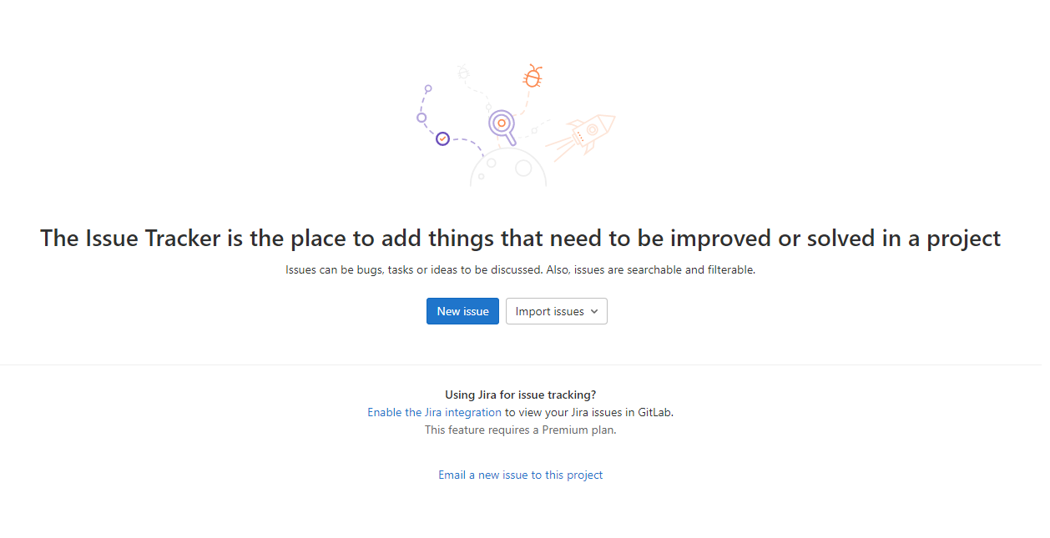

## Detail Of Issue

After Clicking the **New Issue**, a New page opens on which need to write detail related to the issue like

### **Write Title (Required)**

The title means to write the title of the issue, for example, Gitlab 101, Tutorial Video Example, etc.

### **Select Type**

Select the type has two options,

* Issue
* Incident

Select the issue.

### **Write Description**

In the description, the box means to add some detail related to the issue. In the description box, you can add links, attach files, add bullets and perform as many tasks as you want.

* Write
* Add Bold text
* Add italic text
* Add Strikethrough Text
* Insert a Quote
* Insert Code
* Add a Link
* Add a Bullet List
* Add a Numbered List
* Add a Task list
* Add a Collapsible Section
* Add a Table
* Also, see full screen
* Preview
* Attach File
* Support Markdown

### **Tick Box for Confidential**

This means, this box is confidential and should only be visible to team members with at least reporter access. If you want then click OK, otherwise go ahead.

### **Select Assignee**

you can Assign the issue to others as you want but also assign it to yourself by selecting the option assigned to me.

* Assign to me

### **Write Due Date**

Write Due Date.

### **Select Milestones**

Select Milestone.

### **Labels**

Select Label.

### **Create Issue**

Click on Create Issue Button.

### **Cancel**

If you do not want to create issue then click on Cancel Button

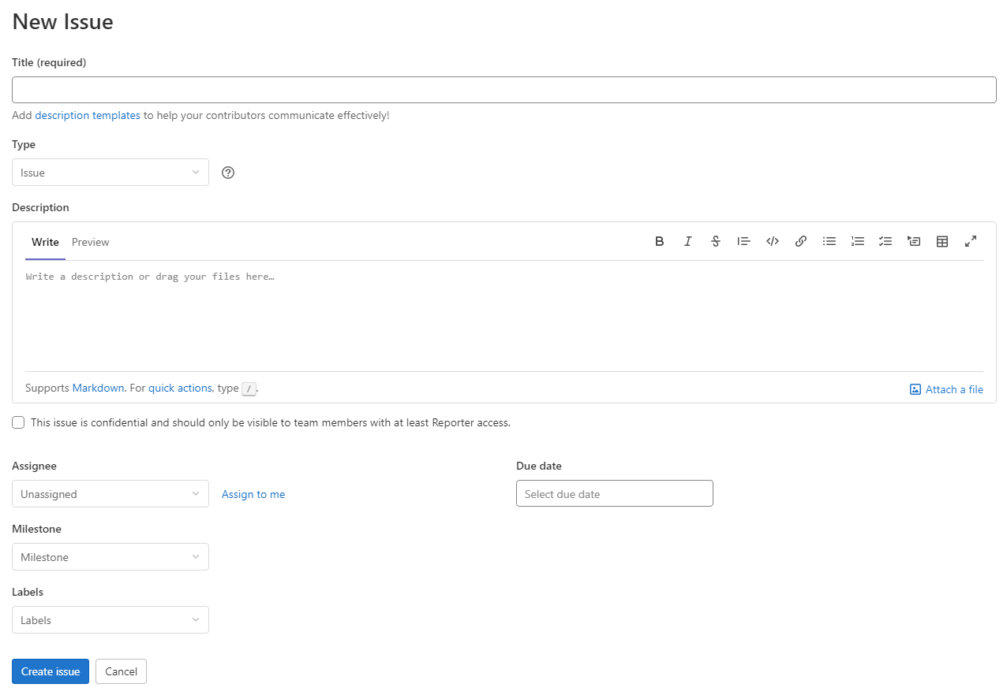

**After creating the issue the new page appears with issues details like:**

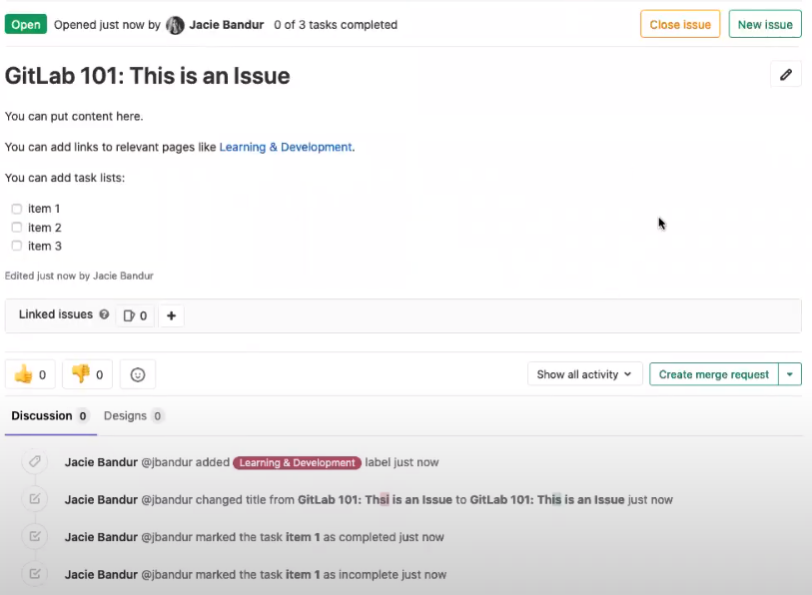

**After creating the issues, then clicking on the list shows all issues in the form of a list.**



 